|  |  |
| --- | --- |
| *Name* | *Bracelet* |
| *Color* | ***Silver*** |
| *Size* | ***2.5 inch*** |
| *Brand* | ***Louis*** |
| *Price* | ***PKR 300*** |

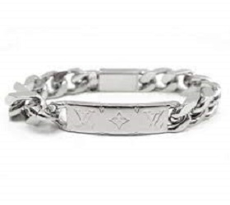

|  |  |
| --- | --- |
| *Name* | *Bracelet* |
| *Color* | ***Black*** |
| *Size* | ***2.2 inch*** |
| *Brand* | ***Louis*** |
| *Price* | ***PKR 350*** |

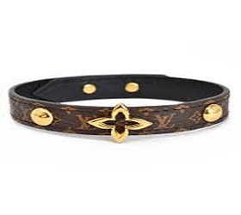

|  |  |
| --- | --- |
| *Name* | *Bracelet* |
| *Color* | ***Silver*** |
| *Size* | ***2.2 inch*** |
| *Brand* | ***Louis*** |
| *Price* | ***PKR 350*** |

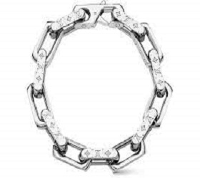

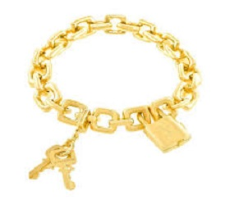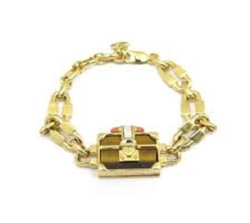

|  |  |
| --- | --- |
| *Name* | *Bracelet* |
| *Color* | ***Golden*** |
| *Size* | ***2.2 inch*** |
| *Brand* | ***Louis*** |
| *Price* | ***PKR 3500*** |

|  |  |
| --- | --- |
| *Name* | *Bracelet* |
| *Color* | ***Golden*** |
| *Size* | ***2.2 inch*** |
| *Brand* | ***Louis*** |
| *Price* | ***PKR 350*** |

|  |  |
| --- | --- |
| *Name* | *Bracelet* |
| *Color* | ***Silver*** |
| *Size* | ***2.7 inch*** |
| *Brand* | ***Louis*** |
| *Price* | ***PKR 350*** |

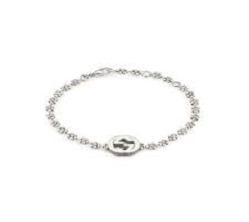

|  |  |
| --- | --- |
| *Name* | *Bracelet* |
| *Color* | ***Dark Silver*** |
| *Size* | ***2.7 inch*** |
| *Brand* | ***Louis*** |
| *Price* | ***PKR 350*** |

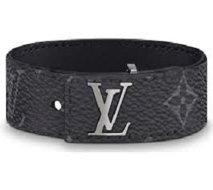

|  |  |
| --- | --- |
| *Name* | *Bracelet* |
| *Color* | ***Golden*** |
| *Size* | ***2.7 inch*** |
| *Brand* | ***Louis*** |
| *Price* | ***PKR 350*** |

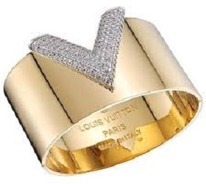

|  |  |
| --- | --- |
| *Name* | *Bracelet* |
| *Color* | ***Silver*** |
| *Size* | ***2.7 inch*** |
| *Brand* | ***Louis*** |
| *Price* | ***PKR 350*** |

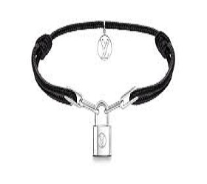

|  |  |
| --- | --- |
| *Name* | *Bracelet* |
| *Color* | ***Golden*** |
| *Size* | ***2.7 inch*** |
| *Brand* | ***Louis*** |
| *Price* | ***PKR 350*** |

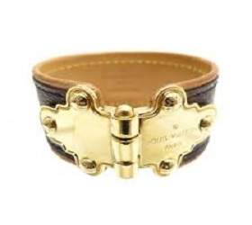

|  |  |
| --- | --- |
| *Name* | *Bracelet* |
| *Color* | ***Black*** |
| *Size* | ***2.7 inch*** |
| *Brand* | ***Louis*** |
| *Price* | ***PKR 350*** |

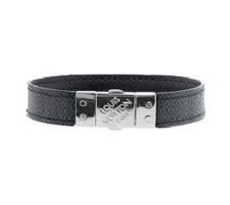

|  |  |
| --- | --- |
| *Name* | *Bracelet* |
| *Color* | ***Silver*** |
| *Size* | ***2.7 inch*** |
| *Brand* | ***Louis*** |
| *Price* | ***PKR 350*** |

